Bahria University,

Karachi Campus



LAB EXPERIMENT NO.

08

LIST OF TASKS

|  |  |
| --- | --- |
| TASK NO | OBJECTIVE |
| 1 | Write a program, which creates an array of 20 elements of type integer and initializes each of the elements with a value equals to the index of the element multiplied by 5. Print the elements to the console. Array[2]=2*5 |
| 2 | Write a program, which reads two arrays from the console and checks whether they are equal (two arrays are equal when they are of equal length and all of their elements, which have the same index, are equal).  Array[6]={1,1,1,2,2,9} , Array2[6]={1,1,1,2,2,2} |
| 3 | Make a program in C# in which take 5 numbers from user and then give sum and avg. of them. Using arrays. |

Submitted On:

____________

**(DD / MM / YY)**

**TASK # 01 :**

Write a program, which creates an array of 20 elements of type integer and initializes each of the elements with a value equals to the index of the element multiplied by 5. Print the elements to the console. Array[2]=2*5

**SOLUTION :**

class Program

{

static void Main(string[] args)

{

int[] arr = new int[20];

for (int i = 0; i < 20; i++)

{

arr[i] = i * 5;

Console.WriteLine(arr[i]);

}

}

}

**OUTPUT :**

**TASK # 02 :**

Write a program, which reads two arrays from the console and checks whether they are equal (two arrays are equal when they are of equal length and all of their elements, which have the same index, are equal).

Array[6]={1,1,1,2,2,9} , Array2[6]={1,1,1,2,2,2}

**SOLUTION :**

class Program

{

static void Main(string[] args)

{

int num1, num2;

Console.Write("Enter the Length of Array 1 : ");

num1 = int.Parse(Console.ReadLine());

Console.Write("Enter the Length of Array 2 : ");

num2 = int.Parse(Console.ReadLine());

int[] arr1 = new int[num1];

int[] arr2 = new int[num2];

Console.WriteLine("");

for (int i = 0; i < arr1.Length; i++)

{

Console.Write("Enter the value {0} of Array 1 : ",i+1);

arr1[i] = int.Parse(Console.ReadLine());

}

Console.WriteLine("");

for (int i = 0; i < arr2.Length; i++)

{

Console.Write("Enter the value {0} of Array 2 : ",i+1);

arr2[i] = int.Parse(Console.ReadLine());

}

if (arr2.Length == arr1.Length)

{

for (int i = 0; i < arr1.Length; i++)

{

if (arr2[i] == arr1[i])

{

Console.Clear();

Console.WriteLine("\t* Both are equal *");

}

else

{

Console.Clear();

Console.WriteLine("\t* They are not equal *");

break;

}

}

}

}

}

**OUTPUT :**

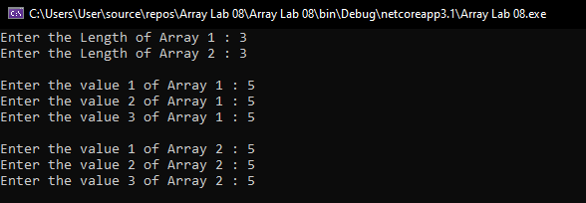**

**TASK # 03 :**

Make a program in C# in which take 5 numbers from user and then give sum and avg. of them. Using arrays.

**SOLUTION :**

class Program

{

static void Main(string[] args)

{

int[] nums = new int[5];

int sum = 0;

for (int i = 0; i < 5; i++)

{

Console.Write("Enter Number {0} : ",i+1);

nums[i] = int.Parse(Console.ReadLine());

sum += nums[i];

}

double avg = sum / 5;

Console.WriteLine("\n\tSum = {0}", sum);

Console.WriteLine("\tAverage = {0:0.00}",avg);

}

}

**OUTPUT :**

